Final Project Report
I want to analyze the population data of various countries to find trends and identify countries with the fastest population growth from the beginning of this century.
The aim of this analysis is to understand the major global trends in population changes by analyzing population data.
This dataset that I used is from the United Nations, I use the following information:
1, Country Name, (country)
2, Year, (year)
3, Total Population(population)
And I have computed the growth rate by the calculation
The source: https://data.un.org/Data.aspx?q=Population+by+country&d=PopDiv&f=variableID%3a12
And I used it in the CSV format, from 2000 to 2023.
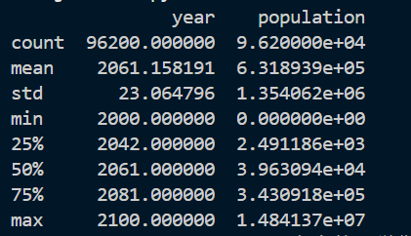
Countries with the highest population: China, India, United States
Countries with the fastest population growth: Nigeria, Ethiopia, Pakistan

The tools that I used:
Pandas, for data manipulation & Matplotlib, for plotting.
Seaborn, for advanced visualization
The idea for the code:
Read the CSV file, rename columns for consistency and remove rows with missing values to ensure data integrity. Then, find the data that is 2000 onwards. The important action: calculate the population growth rate for each country and visualize the top 10 countries with the fastest growth rates.

Result:
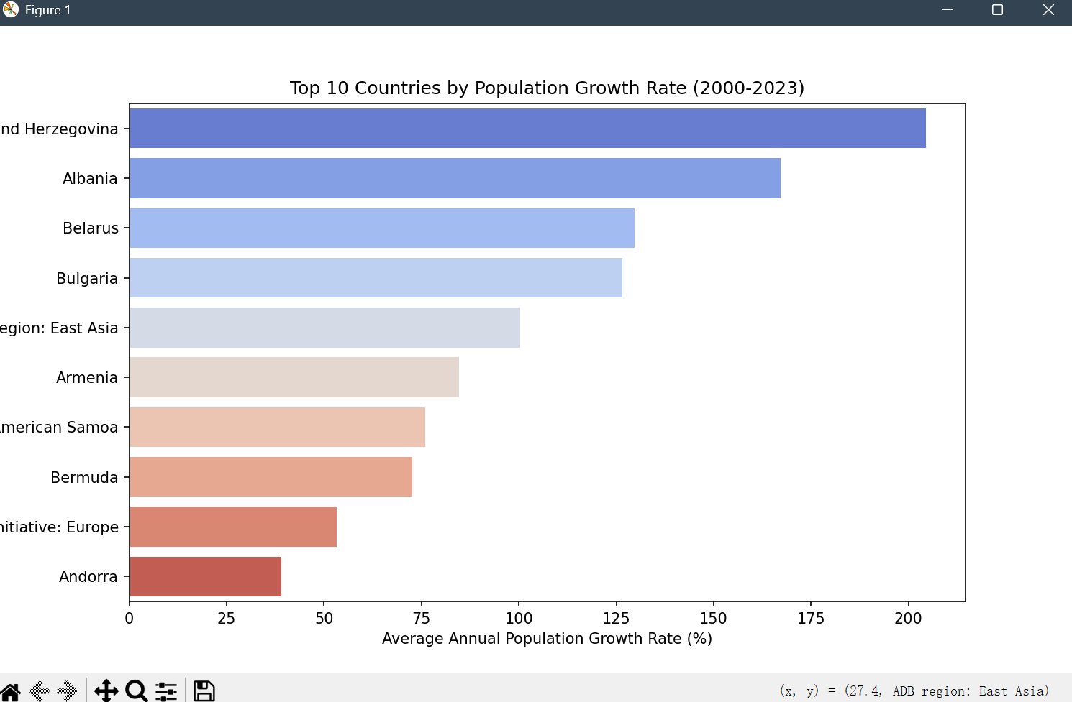
Nigeria, Ethiopia, and Pakistan are the fastest-growing countries in terms of population.
While global population growth is slowing, developing countries maintain relatively high growth rates.

I think I can do the analyze the age structure of populations, to find the proportion of young people. Or I can find the relationship between population growth and GDP and so on.\

